Lesson Plan
Practicum 2: Social Studies
Morgan Wanner

Grade Level: 2

Subject Area: Social Studies

Materials Needed: “Swimmy” by Leo Leonni, activeboard, powerpoint slideshow, 3 drawings template with pencils (optional activity)

Standards:
2.4.1 Identify roles and responsibilities of leaders in the home, school, and community (e.g. parents, teachers, principal, mayor, governor, president)

Objectives: Students will be able to identify the qualities of leaders.

Learning Activities:
- Students will sit on the floor in the front of the room for a class discussion.
- Tell the students that they will be learning about leaders in this lesson.
- Question: What does the word leader mean? What are the qualities/characteristics of a leader?
  - Discuss qualities
  - Write student responses on the activeboard
    - Helpful
    - Responsible
    - Positive
    - Make good choices
    - Solve problems
    - Do not give up
    - Do the right thing
    - Believe in themselves and others
    - Role model
    - People look up to them
- Students will be asked to close their eyes and think of someone who is a leader in their life.
- “Turn and talk” with the peer next to them about the leader in their life.
- Gather attention by counting down from 5 and clapping if needed.
- Call on a few students to share.

- Teacher will read the book “Swimmy.”
  - Remind students to recall and be looking for the characteristics of a leader.
- Ask students to raise their hands at the end of the book if they thought Swimmy was a leader.

- Question: What kind of characteristics made Swimmy a leader?
  - Possible responses
    - He recognized and solved the problem
    - He helped out the other fish
    - He kept the other fish safe
    - He led the school of fish
    - He didn’t give up
    - He was positive that they could think of a solution
    - He was a good friend to all
- Students will then be asked to think about the word leader on many levels
  - Home, classroom, school, city, state, and country
- Teacher will call on students to think of the leader in each of these communities.
  - Parents/guardians, teacher, principal, mayor, governor, and president
- Question: Do you think that each leader has the same responsibilities? Why not?
- Discuss why parents have different roles than the president, etc.
- Question: What would happen if we didn’t have leaders?
- Talk about how students can be leaders as well! Have students give a thumbs-up if they think they can be a leader.

- Movement game
  - Tell students that you are going to check if they know what the responsibilities are of each leader.
  - Have all students stand up.
  - Explain that there are pictures of each leader (parents, teacher/principal, city, and me) posted around the room.
  - The teacher will go through a powerpoint slideshow of pictures.
  - Students will decide which leader has that responsibility and go to that spot in the room. (Ex. a picture of a child having a meal illustrates the responsibility of a parent cooking for that child)
  - A very short discussion will be had after each slide.
  - The students will sit back down at the front of the room when the game is over.
- Ask for other examples of how they can be leaders in several communities (at home, at school, in the town)

- (If time allows) Give a few examples and ask the class if the child was being a leader in the scenario.
  - Mrs. B’s class was outside for recess. Most of the class was playing basketball together, but a few kids were playing on their own. When Peyton was just about to shoot and score a point for his team, he saw that Hannah was crying because she was hurt from falling off the monkey bars. Peyton put the ball down and ran to help her.
    - Sacrifice

  - Karlee’s mom and older brother were in a hurry to get the dishes done. They wanted to get to the store before it closed that night. Just then, the phone rang and Karlee’s mom needed to step away to answer it. Karlee saw that her brother was now doing the dishes by himself and that he may not get them done in time to go to the store anymore. Karlee thought about helping her brother so that the dishes could get done faster, but decided she would rather go play with her toys in her room.
    - Helpfulness
  - One morning after a blizzard Andrew was getting on the bus when he saw that his elderly neighbor, Mr. Johnson, was having a tough time shoveling the heavy snow off of his driveway. He watched him shovel very slowly as he got on the bus. When he got home from school that day, he realized that Mr. Johnson still had a lot of snow left on his driveway. He thought to himself, “I wonder if it was too hard for him. Maybe he needs some help.” Andrew went to the neighbor’s house and shoveled off his driveway. He didn’t hear a word from Mr. Johnson after that and wondered if he even noticed his hard work. This made Andrew sad, but every day that there was a blizzard, he woke up and shoveled off Mr. Johnson’s driveway for him before going to school.
    - Perseverance
    - Didn’t give up
    - Did the right thing
    - Helping

- Optional: Students will go back to their desk and draw pictures of themselves (or write if they wish) being a leader in their home, school, and community. (template attached)

Assessment: Students will be assessed on participation in the class discussion and activity. If optional activity was used, completion of their independent drawings will be assessed as well.

Reflection: What went well that I would keep the same during this lesson?
The book illustrated a leader really well for the students. The turn and talk worked out perfectly because everyone wanted to talk about a personal leader. Everyone wanted to share after this as well. This was a good personal connection for them. I only posted 4 of the several posters I printed off to make it easier for the students.

If I were to teach this lesson again, what would I need to change?
The expectations need to be clearer before beginning the movement game. The students didn’t behave the way they were asked and had to sit back down on the floor. Since they were not able to do the game in a safe manner, they had to point to the pictures instead of moving. I planned too many activities for one lesson. I didn’t do the independent activity, but next time I would stop back at the movement activity.

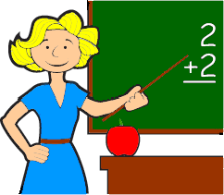
Teacher

Me

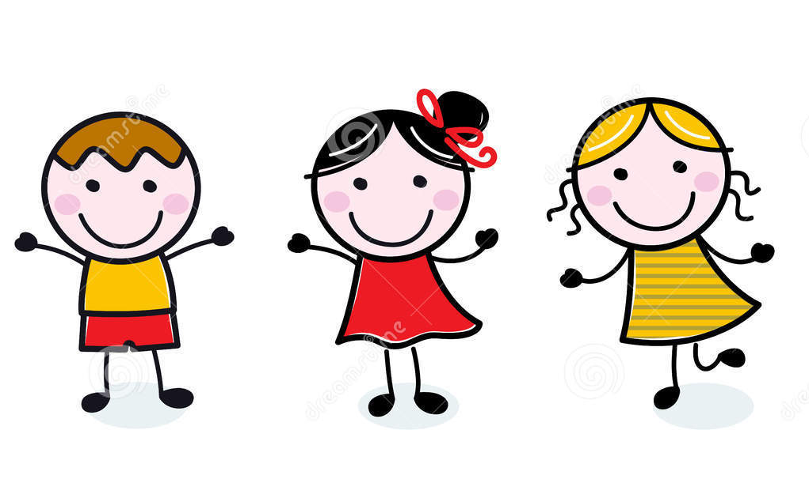

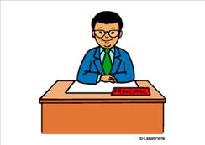
Principal

Bismarck
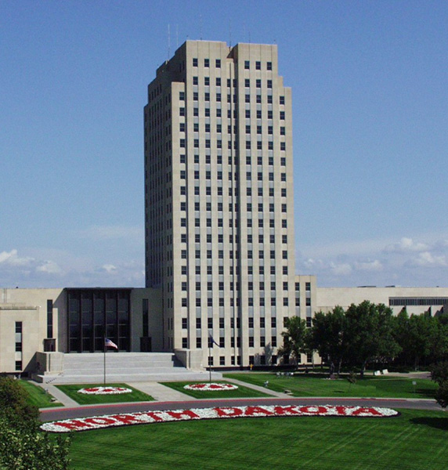

Parents
